Rocket Trajectory Visualisation Tool – Future Development

Report prepared by Heather Leyssenaar

Recommendations are based on work completed by project developers:
Luke Gerschwitz,
Alyssa Yeo,
David Galbory, and
Heather Leyssenar.

Table of Contents
Rocket Trajectory Visualisation Tool – Future Development 1
Introduction 1
Next Steps – Creating the dataset(s) 2
Configuring Unity to display the graph based on new data 6
Additional Work 7

Introduction
The Rocket Trajectory Visualisation project, developed for Swordfish Computing, has had the following major features added:
- Additional datasets that change show changes in alternative input variables (as opposed to only mass over time) have been added.
- The user can use the new datasets to generate new graphs at runtime, by accessing a user menu that is linked to the left controller
- Graphs can be deleted from the scene at runtime
- Multiple graphs can be spawned around the user, and displays are updated if a graph is deleted
- Graphs can be regenerated when axes have changed.
- New output variables are automatically read in to the project and can be displayed to a data panel
- Added support for different controllers (HTC Vive)
- The user can choose the axes of the graph via a menu panel
- The user can choose to generate a 2D or 3D scatter-graph
- The user can choose to generate a bar graph or a scatter-graph
- The user can highlight a trajectory with a slider and view updated information about that trajectory in the data panel and on the graph config menu.
- The information displayed on the data panel can be customised by using the data control panel and checking or un-checking the related variable checkbox. The data panel also has a slider control to view larger amounts of data.
- The user can configure existing graphs by using a configuration panel
- Most menu panels can be minimised to reduce screen clutter, and then brought back to original size
- Some quality of life features such as background colour, sound effects, movable data windows and loading time visual cues.

Future Steps
A potential future step was identified, which was adding another layer of abstraction to the graphs.
Applying Ladder of Abstraction concepts to the project can be most easily achieved by adding datasets with additional variable changes for the user to select from the graph menu.

Rather than abstracting the change of a single variable over time, the source data can be generated with two (or more) input variables being changed for the rocket trajectory simulations.

Next Steps – Creating the dataset(s)

In the Assets/Resources folder of the project, the colabRocketpyv2_1 file will give the quickest starting point. This file should be run in Google Colab to prevent dependency errors. Mount the file according to instructions that can be found in the manual. (The manual can be found on the GitHub repository for this project).

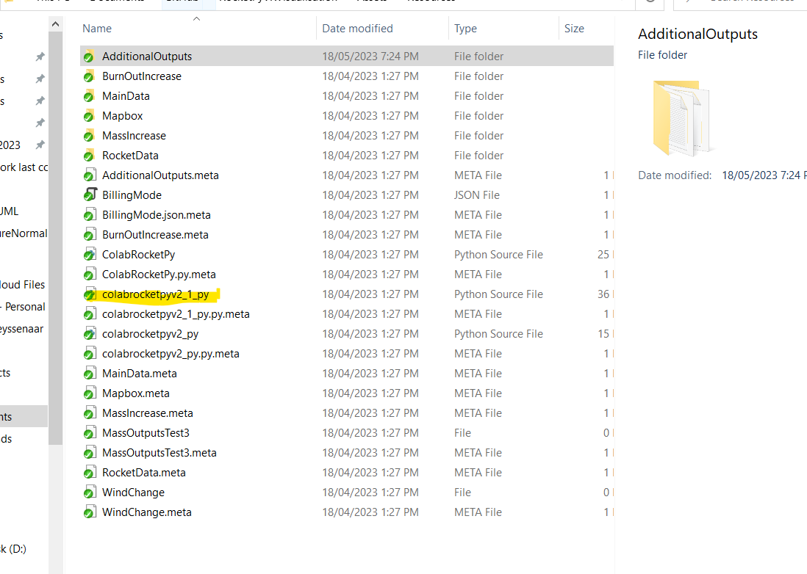Figure 1: Location of Google Colab file
If you wish, you can copy or rename the file to preserve the older version.
Follow the steps laid out in the file, correcting any errors that may be raised by missing folders (instructions also found in the manual).

Each code block is called a ‘cell’. Run any cell that isn’t marked as optional until you get to choosing variable types. This can be done by clicking in the cell, then holding “Ctrl + Enter”.
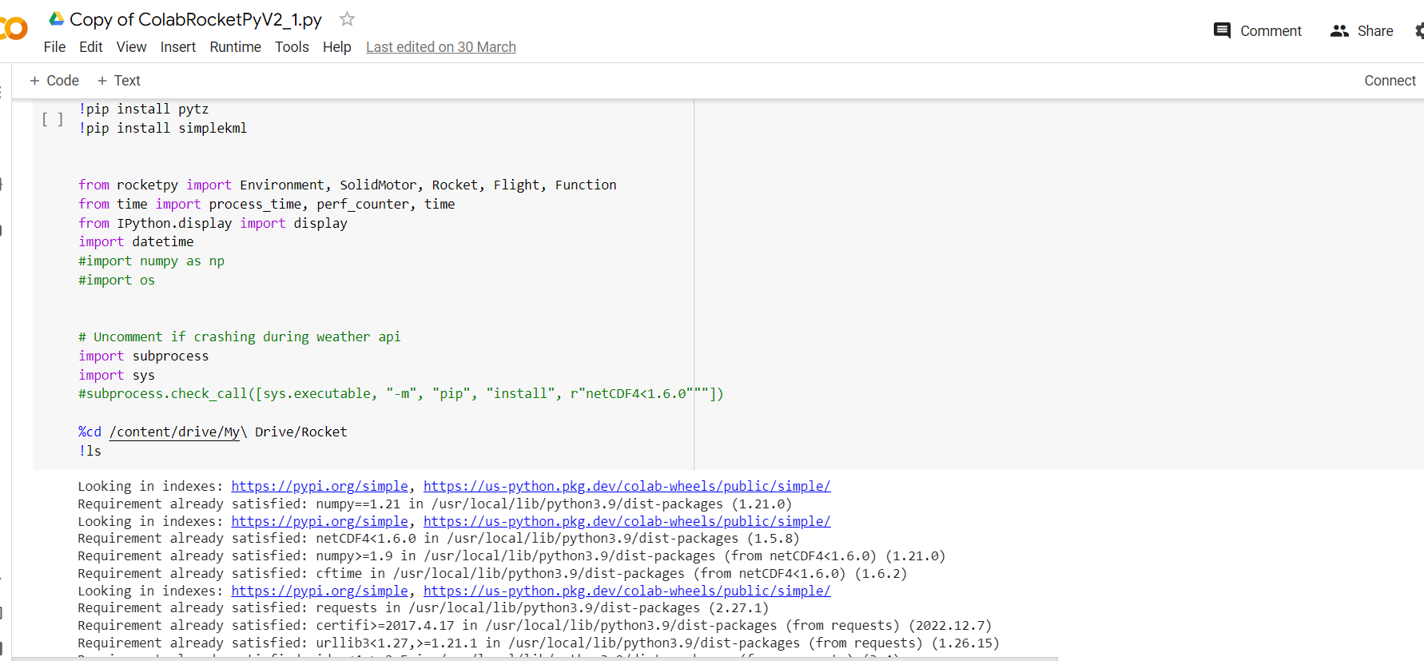Figure 2: Colab file first cell
Note on naming the folder: The folder name should indicate what two variables are being chosen, but due to space restrictions on the graph menu, the name should not be too long.
Something like “Mass_Temp” would be ideal for increasing mass and temperature together, for example.

Run the cells that choose the initial variable, the starting value, and the step value (how much the value increases or decreases). Below these code cells, add a cell to the file for extra variables. An example is shown below. You will be adjusting these values manually, so be sure to choose appropriate step sizes (the amount the variable will change over the simulations).
While not strictly necessary, we are adding secondVarEnabled so that we can easily switch back to single variable changes without reverting all code changes. You may also wish to change the starting variable value. If so, add it here too.
If you will be re-running the file with different variables to use as the second variable, it is a good idea to name secondVarEnabled as something more appropriate to the actual name, and set it to zero, so that you do not have to remove the extra code. This also applies to the step variable and the starting variable (if used).

.
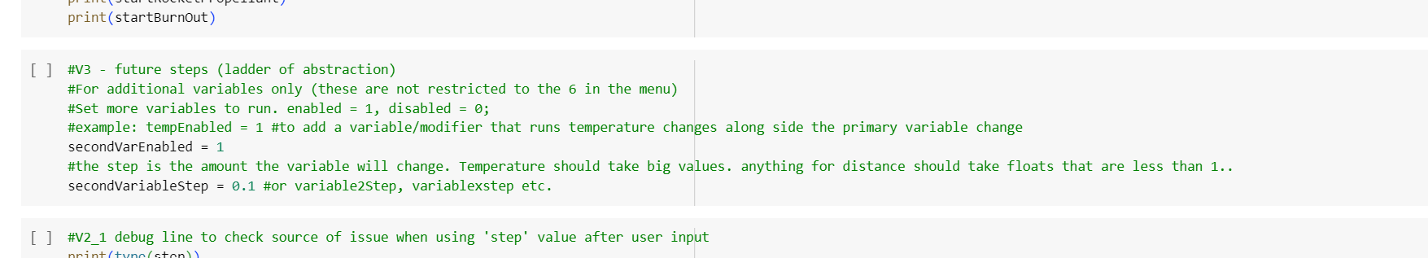Figure 3: Example code to be added to the file and then run
Then look for this section in the main simulation code (marked by #V1).

.
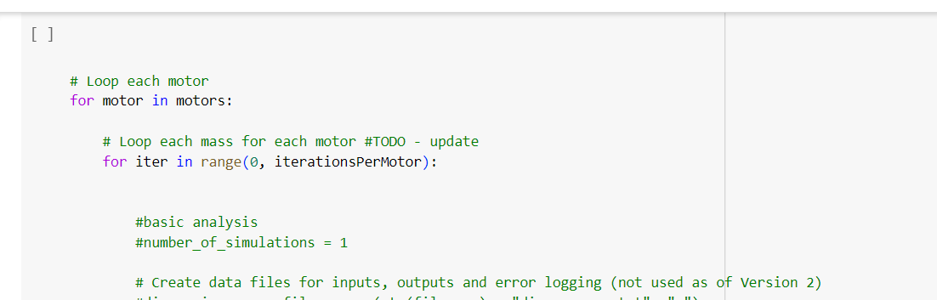Figure 4: Main simulation loop code
Go down to where the variables are defined.
Choose the variable to change and modify the line so that it will be increased
You can use any variable that can be found in the all_inputs.csv file (There should already be one generated for Default_Inputs in Assets/Resources/AdditionalOutputs if you need examples).
You’re going to add something like the blue highlighted section to your chosen variable.

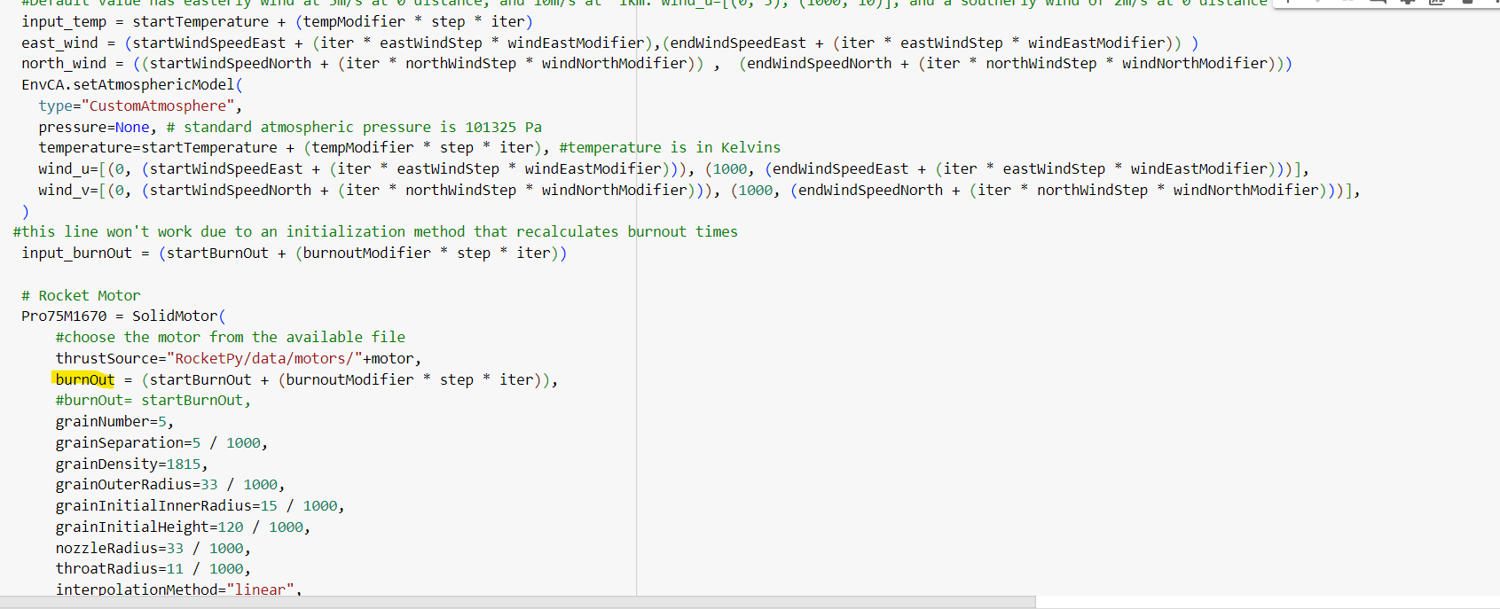
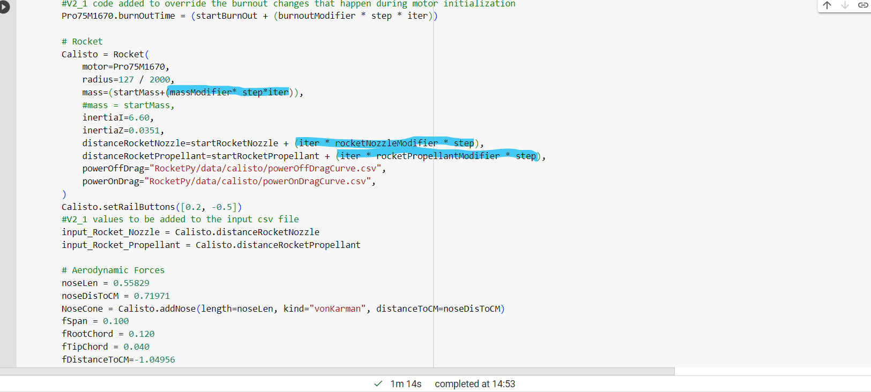Figure 5: Examples of existing primary variable that can be changed via the menu

The adjustment will be to add (iter * secondVarEnabled * secondVariableStep) to the end to the line. The below is an example of choosing something already shown in all_inputs.csv, but was not yet used as a changing variable.

.
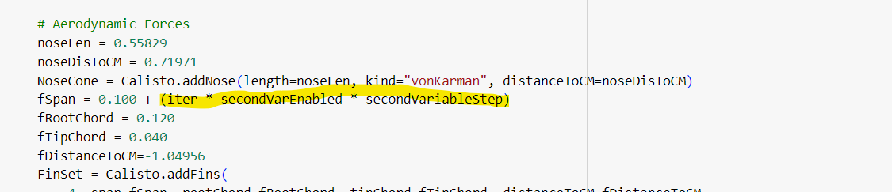Figure 6: Second variable (fSpan) that will be changed over the simulations
Alternatively, if you wish to use two of the originally changeable variables, run the cell with the menu to set up the primary variable, and add the following to the secondary variable:

.
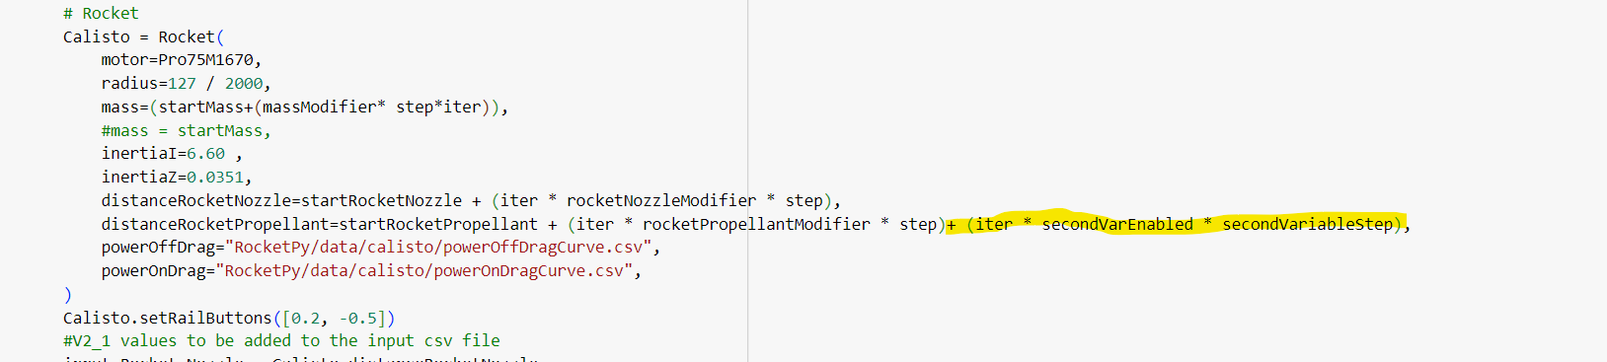Figure 7: Using a variable that was already possible to use as primary input as a secondary input
Run the cell. If correctly simulated (note that this will take a few minutes), you will find generated csv files in your Google Drive.

This folder can be downloaded and added directly to the AdditionalOutputs folder. (Be sure that the files are not compressed).
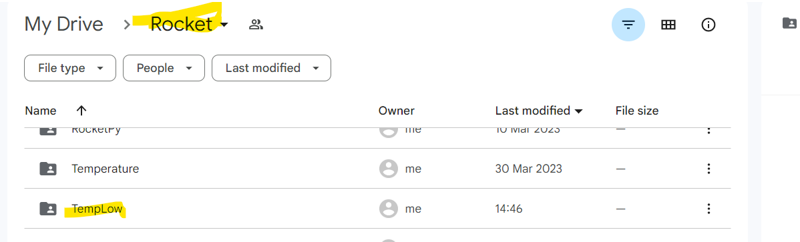Figure 8: Where to find the generated files in Google Drive

Configuring Unity to display the graph based on new data
The Unity project already has code that checks for data in the resources folder. The graph can be generated and displayed by launching the program, then using the folder name that will show up in the Input Conditions drop-down menu.

But to allow the graph config menu to track the variable changes, you need to go to the variable focus mapping text file found in the AdditionalOutputs folder.

.
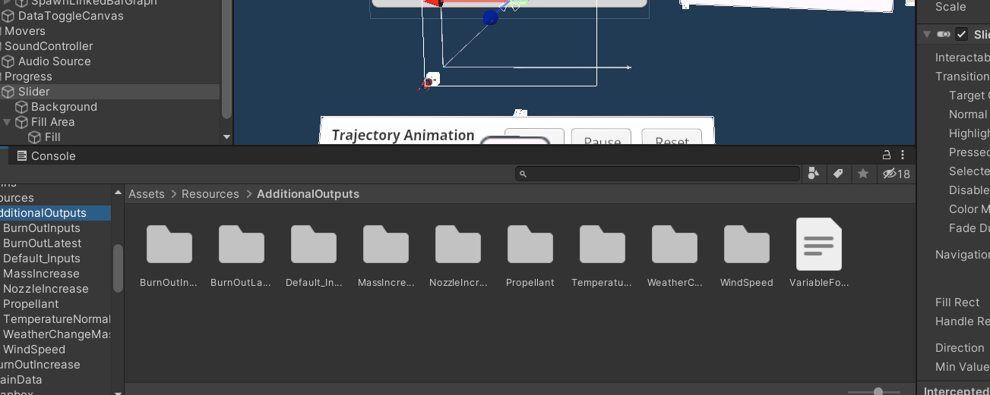Figure 9: Location of VariableFocusMapping file
Copy your folder name exactly and add it to the file.

.
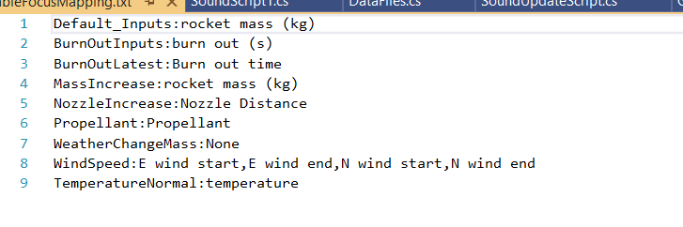Figure 10: Existing input folders mapped to their primary input variable
Then you need to match it to the input or inputs that are being changed.
Choose one of the two variables to focus on
(Future development may include having a secondary file to check for additional variables, but for now pick one).
You will find the exact column name in the all_inputs.csv file.

.
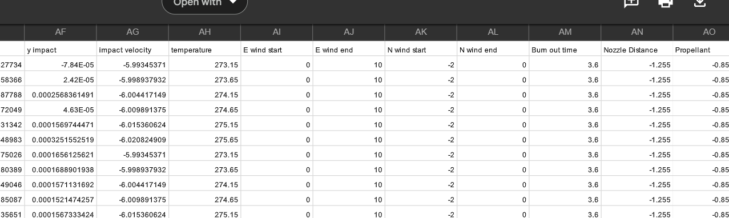Figure 11: One of the all_inputs.csv files that has been generated
After a ‘:’, paste in the column name next to it’s folder name.
Now the variable details will be updated on the graph config menu panel when the trajectory changes.

Additional Work
The GraphConfig file (attached to every generated graph) accesses the trajectory data and extracts the focus data information from it.
This information is then accessed by the script that controls the graph config menu, GraphConfigMenuScript.cs. Shown below is the function “updateSliderValue”
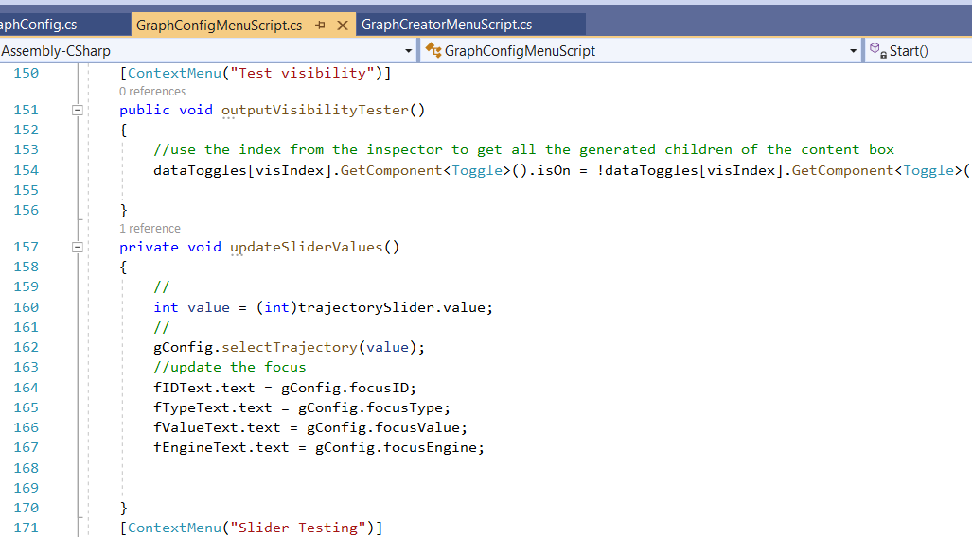Figure 12: Where the menu gets the focus values from
At present, when the slider is moved, only the single variable listed in the VariableFocusMapping file is tracked and used to update the screen.
The function used to do that is selectTrajectory in GraphConfig. As seen below, the CSV data is parsed to get the values based on the trajectory index.

A possible next step would be to determine how best to display the secondary variable and it’s values to the screen when the slider is moved. This might mean checking a secondary file for the input folder name and the secondary variable.

.
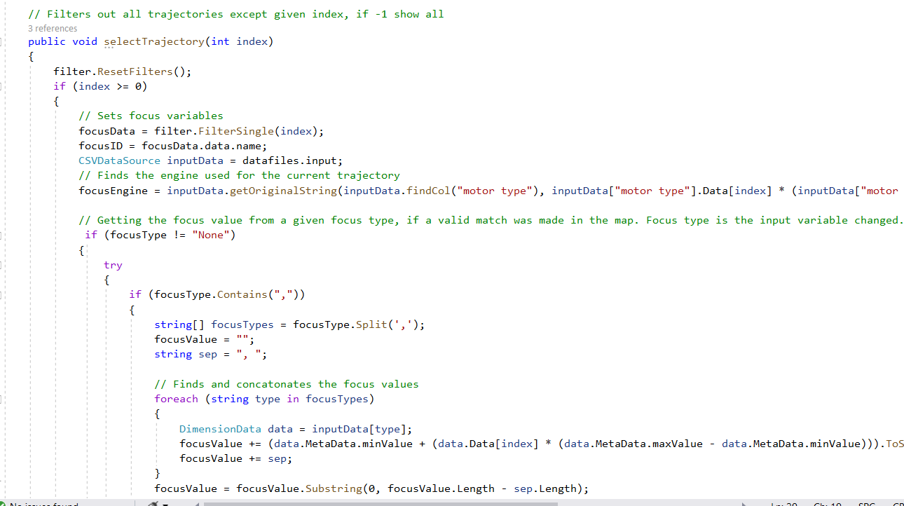Figure 13: selectTrajectory method in the GraphConfig script
The getFocusType code is inherited from GraphCommon

.
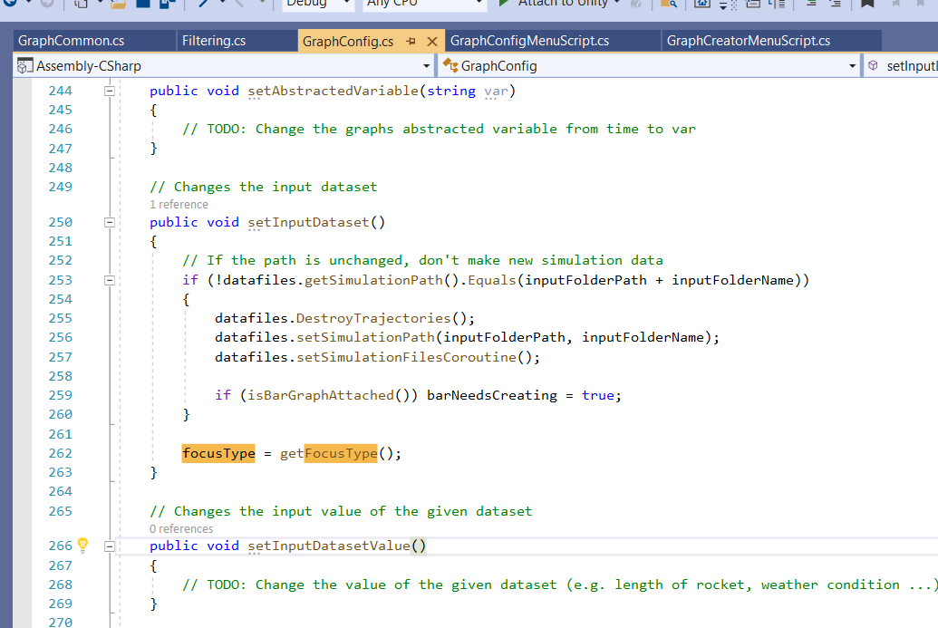Figure 14: Where the focus Type is called in from GraphCommon within setInputData
The code may, in the future, be adapted to retrieve a secondary focus type from either the variableFocusMappingFile or a new file created to hold secondary variable types.

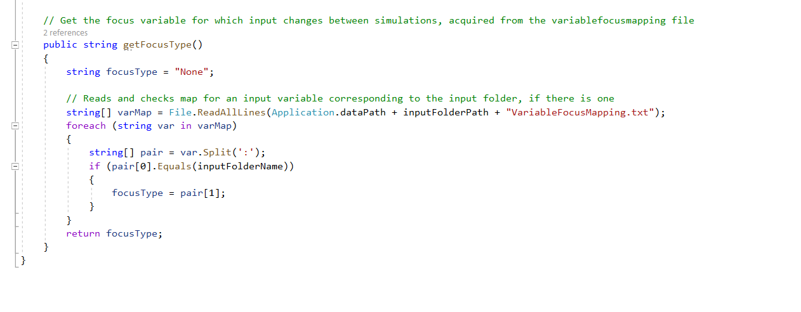Figure 15: getFocusType from GraphCommon
A more complicated task might be to connect multiple single variable datasets to the same axes and layer them over each other. All sets except the currently selected set would be hidden from sight. A click of a button could cycle through the set, allowing a better view of how changing the inputs will affect the outputs, as even small changed would be easier to detect. This would require more work with the IATK, and also possibly some custom work. This is a task that is not really necessary, since multiple datasets can already be displayed in the same scene for comparison.

